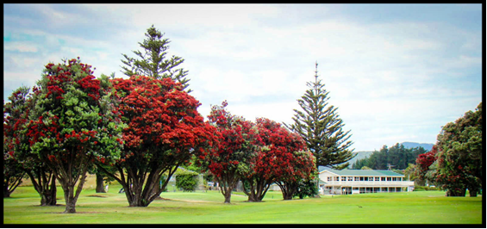

WAIKANAE GOLF CLUB LADIES OPEN DAY
THURSDAY 3RD MAY 2018 (RESCHEDULED DATE)

9.00 a.m. Registration, 9.30 a.m. Multi-Tee Start

COMPETITION: Women’s Pairs Stableford
- 6 Holes 4BBB
- 6 Holes Foursomes
- 6 Holes Ambrose
PLUS: Nearest to the pin and longest drive

ENTRY FEE:
$40 per pair (includes lunch) payable to Waikanae Golf Club account 02-0591-0046747-000, reference - surname, club no., code - 7084

ENTRIES CLOSE: Monday 30th April 2018

SEND ENTRIES TO:
Ann Hanlon Email: wgcladies18hole@gmail.com
Phone: 04 293 2117 or 0274 308185 (include club 7 digit code and handicap index)

