

presents the

**2018 Sims Cup**

**18 HOLE JUNIOR OPEN TOURNAMENT**

***MONDAY DECEMBER 17th***

***(Shotgun start at 10am)***

Entry fee $20

Gross, net & stableford competition

*To be eligible, entrants must be under 19 years of age*

*Entries close Saturday December 15th*

*Entries on the attached form are to be sent to:*

[*office@otakigolfclub.co.nz*](mailto:office@otakigolfclub.co.nz)

* Phone: 06-3648260*

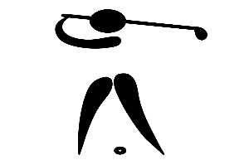

*ENTRY FORM for SIMS CUP*

*Entries to: Otaki Golf Club Inc.*  Phone: 06-3648260

Email: [office@otakigolfclub.co.nz](mailto:office@otakigolfclub.co.nz)

Please enter me for the Sims Cup Junior Tournament on Monday December 17th 2018: Shotgun start at 10am.

NAME: ________________________ Contact phone: ___________

CLUB: ________________________ Handicap Index: __________

Email address: ___________________________________________

*Please pay the entry fee of $20 to the following bank account (with your name and ‘Sims’ as reference):* ***ANZ Bank: 06 0541 0295892 00***

*Entries close Saturday December 15th.*

________________________________________________________________

*ENTRY FORM for SIMS CUP*

*Entries to: Otaki Golf Club Inc.*  Phone: 06-3648260

Email: [office@otakigolfclub.co.nz](mailto:office@otakigolfclub.co.nz)

Please enter me for the Sims Cup Junior Tournament on Monday December 17th 2018: Shotgun start at 10am.

NAME: ________________________ Contact phone: ___________

CLUB: ________________________ Handicap Index: __________

Email address: ___________________________________________

*Please pay the entry fee of $20 to the following bank account (with your name and “Sims’ as reference):* ***ANZ Bank: 06 0541 0295892 00***

*Entries close Saturday December 15th.*

________________________________________________________________