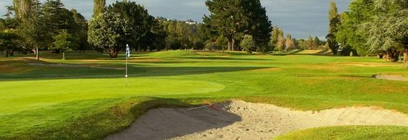

Manor Park Golf Sanctuary
Nine Hole Open Day
(for all active registered 9 Hole members , Ladies and Men)
MONDAY 6TH NOVEMBER 2017
Shotgun Start 10.00am
Morning Tea 9.00am
3 Ladies Divisions
1 Men’s Division
Competition – Stableford
Longest Drive, Nearest the Pin, Holes in 2

Entry $15 (includes morning tea & holes in 2)
Entry fee with your registration would be appreciated plus player handicap and 7 digit computer ID)
Entries Close 30 October 2017
REGISTER EARLY AS FIRST 80 PAID REGISTRATIONS WILL BE ACCEPTED
Single payment per club is preferred by bank transfer – BNZ 02 0528 0095415 000
Please use Reference – 9OPEN and club name
Registrations to: barb.graynz@gmail.com or Barbara Gray, 48 The Strand, Wainuiomata,
Phone 027 267 8387
Registration Form for Golf Open Day on 6th November 2017 at
Manor Park Golf Sanctuary
Registrations Close 30 October 2017
Please send to: barb.graynz@gmail.com or Barbara Gray, 48 The Strand, Wainuiomata.
Phone 027 267 8387
Payment by cheque/bank transfer BNZ 02 0528 0095415 000
Please use reference – 9OPEN and club name
From: (Club Name)……………………………………………………………………………………………………………………………
Club Contact Person……………………………………………………Tel/email:…………………………………………………….
Players from our club are:
Name | Club ID | Member No. | H/cap index | Paid

